2.Create two simple html pages named “page1.html, page2.html” then use the suitable
directive to automatically redirect from localhost/page1.html to
localhost/page2.html.

sudo nano /var/www/html/q2/page1.html

sudo nano /var/www/html/q2/page2.html

<!DOCTYPE html>
<html>
<body>

<h1>Page 1</h1>

</body>
</html>

sudo nano /var/www/html/q2/.htaccess
Redirect 301 /q2/page1.html /q2/page2.html
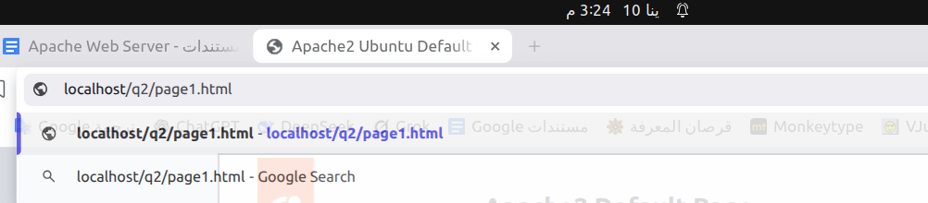
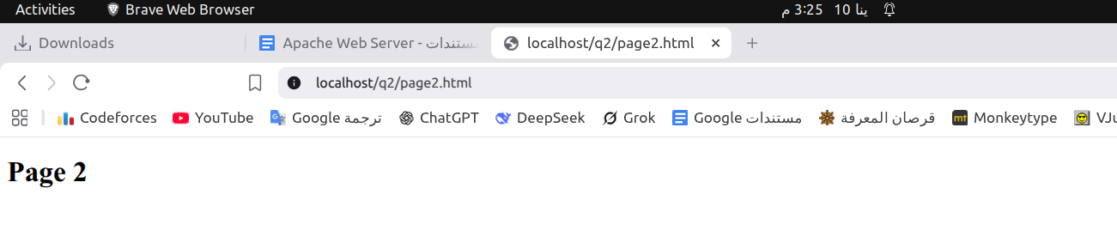

3. Ask for user name and password when accessing a directory
sudo nano /var/www/html/q3/secure/.htaccess
AuthType Basic
AuthName "Authentication Required"
AuthUserFile "/var/www/html/q3/.htpasswd"
Require valid-user
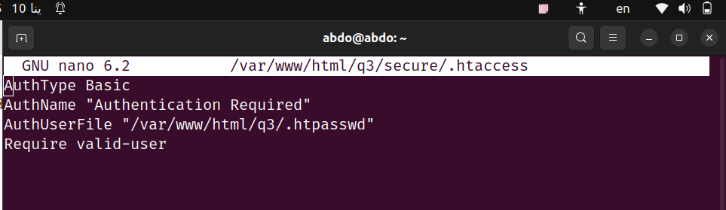
sudo htpasswd -c /var/www/html/q3/.htpasswd abdo
sudo nano /var/www/html/q3/secure/index.html
sudo nano /etc/apache2/apache2.conf
<Directory /var/www/html/q3/secure>
AllowOverride All
</Directory>
sudo service apache2 restart
http://localhost/q3/secure/
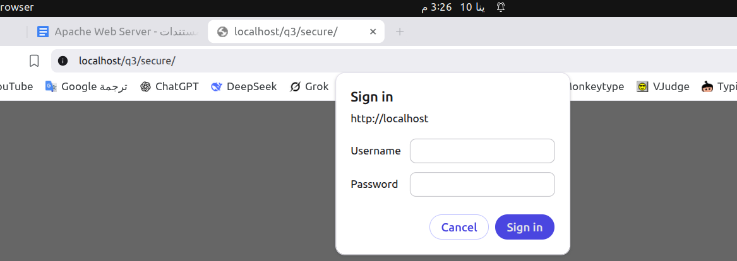
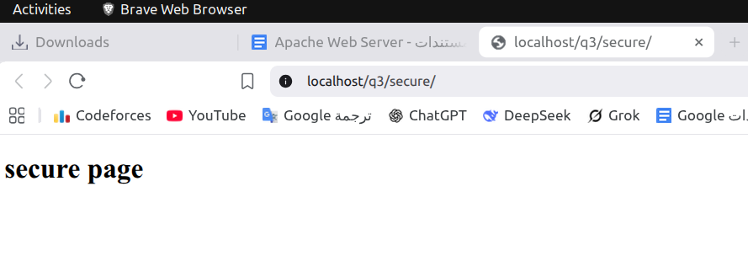
4. Apply authentication before downloading PDF files.
sudo touch /var/www/html/q4/document1.pdf
sudo touch /var/www/html/q4/document2.pdf
sudo touch /var/www/html/q4/doc.html
sudo nano /var/www/html/q4/index.html
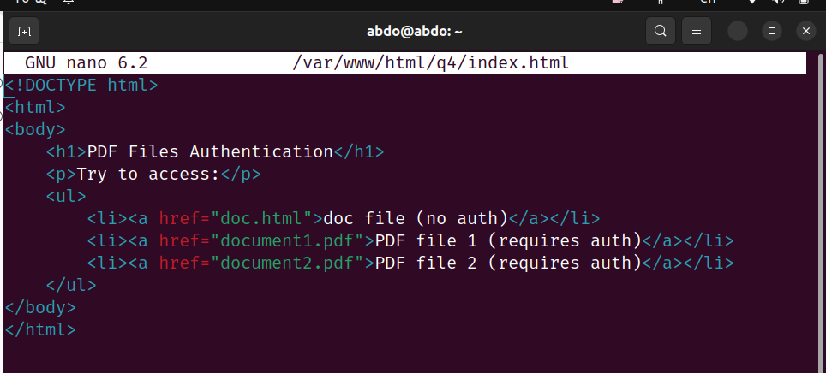
sudo nano /etc/apache2/apache2.conf
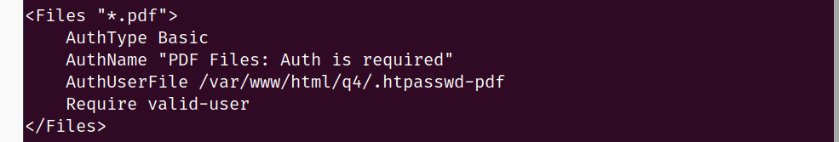
sudo htpasswd -c /var/www/html/q4/.htpasswd-pdf pdfuser

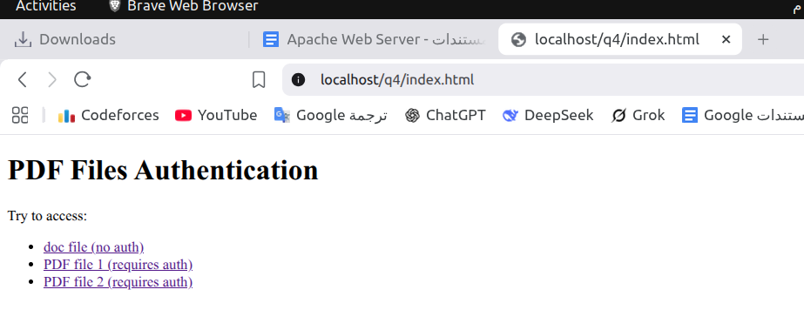
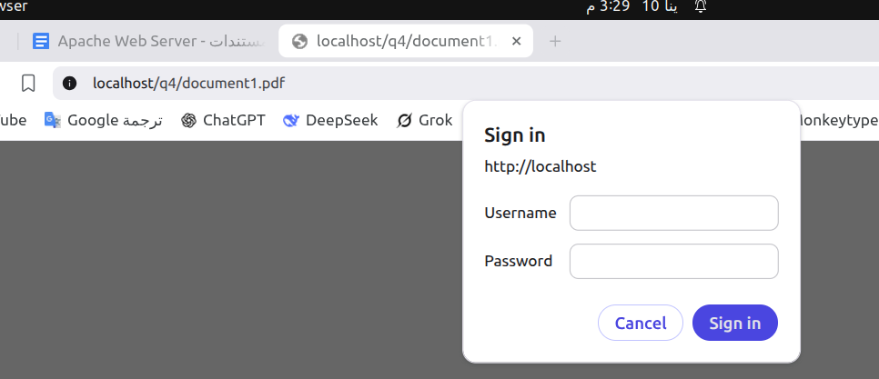
5. Create a directory then allow access to one of your classmates only.
sudo nano /etc/apache2/apache2.conf
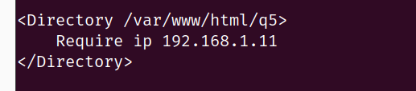

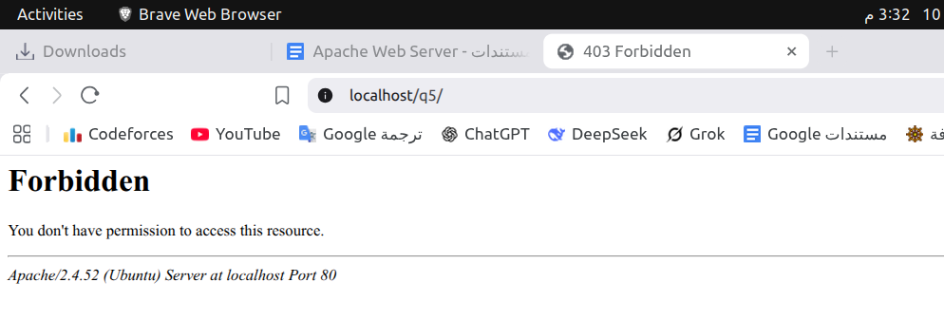
6. Disable listing the directory content (hint use indexs)
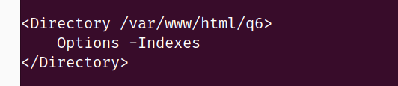

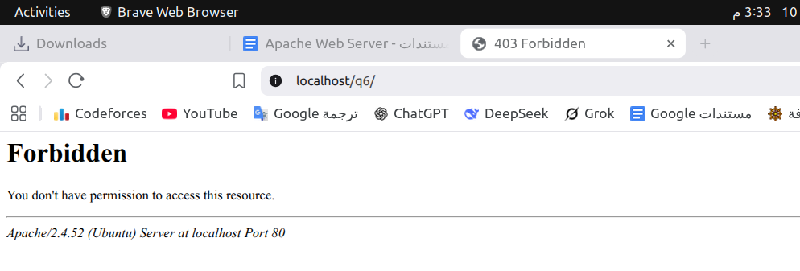
7. Change the default index page to be default.html instead of index.html (use DirectoryIndex)
sudo nano /var/www/html/q7/.htaccess
DirectoryIndex default.html
